Joseph Silva Jr.

SNHU

CS 340

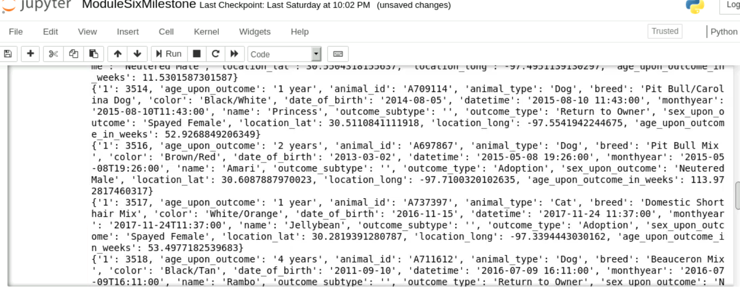

DF table and Geolocation not coming out as an output.